Automated Text Summarization for News Articles

M.N. Sihanas
School of Computing
British College of Applied Studies
Sri Lanka
1030371@bcas.ac
A.L.F. Sajeetha
School of Computing
British College of Applied Studies
Sri Lanka
sajeetha@bcas.ac
A.R.M. Nizzad
School of Computing
British college of Applied Studies
Sri Lanka
nizzad@bcas.ac

Abstract—This paper presents an automated text summarization system specifically designed for news articles, employing the T5-base and BART-base models. The focus is on abstractive summarization techniques, with a comparative analysis of the performance of both models using ROUGE scores. The T5-base model outperformed BART-base in terms of ROUGE metrics, leading to its selection for the final implementation. The system is implemented using a Streamlit interface, enabling user-friendly interaction. This paper details the methodology, implementation process, and results obtained from the evaluation of both models.
Keywords—Text Summarization, Abstractive Summarization, T5-base Model, Bart-base, Natural Language Processing (NLP), SAMSUM Dataset, ROUGE Metrics, Hugging Face, Streamlit

Introduction

In an era characterized by an overwhelming influx of information, particularly in the form of news articles and dialogues, there is a growing need for effective summarization techniques that can distill essential information from lengthy texts [1]. The sheer volume of content generated daily poses challenges for readers who seek to stay informed without investing excessive time in reading full articles. Automated text summarization serves as a critical tool in this regard, enabling readers to grasp key insights without having to sift through extensive content [2].
This research focuses on developing an automated text summarization system that utilizes advanced natural language processing (NLP) models—specifically T5-base and BART-base—to generate high-quality abstractive summaries tailored for news articles. The choice of these models is motivated by their state-of-the-art performance in various NLP tasks, including summarization.
The dataset used in this study is the SAMSUM dataset, which consists of dialog-style human-written summaries. This dataset is particularly relevant as it provides rich contextual information that can enhance the performance of summarization models by training them on conversational data. By leveraging this dataset, we aim to improve the quality and relevance of generated summaries [3].
Abstractive summarization differs from extractive methods by generating new sentences that capture the essence of the source material rather than merely selecting existing sentences [4]. This approach not only enhances the coherence and fluency of generated summaries but also allows for greater flexibility in expressing information. The objective of this study is to compare the performance of T5-base and BART-base models in generating summaries and to implement a user-friendly system using Streamlit that allows users to input articles and receive concise summaries.

Related Work

The field of automated text summarization has witnessed significant advancements over recent years, driven by the development of transformer-based models such as BART and T5 . These models have fundamentally changed how text summarization is approached by utilizing attention mechanisms that allow them to understand context better than previous architectures.
Numerous studies have explored various architectures and techniques to improve summarization quality. For instance, research comparing BART and T5 has shown that while both models excel in generating coherent summaries, their performance can vary based on dataset characteristics and evaluation metrics [1]. BART has been recognized for its efficiency in generating summaries for medium-sized articles due to its bidirectional context understanding and ability to reconstruct sentences effectively.
Previous studies have highlighted that T5 often achieves superior ROUGE scores in specific contexts, indicating its effectiveness in preserving semantic meaning during summary generation [5]. The flexibility of T5 allows it to be fine-tuned for various tasks beyond summarization, making it a versatile choice for NLP applications. This paper builds upon these findings by conducting a direct comparison of both models within the context of news article summarization using the SAMSUM dataset, thereby contributing to the ongoing discourse on optimal approaches for automated summarization [3].

Methodology

Model Selection
The primary models evaluated in this study are T5-base and BART-base. Both models are pre-trained transformers designed for various NLP tasks, including text summarization. The decision to use these specific models stems from their proven track record in producing high-quality outputs across different domains.
T5 (Text-to-Text Transfer Transformer) converts all NLP tasks into a text-to-text format, allowing it to leverage its architecture across multiple tasks seamlessly. BART (Bidirectional and Auto-Regressive Transformers), on the other hand, combines bidirectional encoding with autoregressive decoding capabilities, making it particularly effective for generating coherent text outputs [1], [6].

Evaluation Metrics
The performance of each model is assessed using ROUGE scores (Recall-Oriented Understudy for Gisting Evaluation), which measure the overlap between generated summaries and reference summaries [5]. Key ROUGE metrics include:
- ROUGE-1: Measures unigrams (single words) and evaluates the basic recall aspect.
- ROUGE-2: Measures bigrams (two consecutive words) to assess how well phrases are captured.
- ROUGE-L: Measures the longest common subsequence between generated and reference summaries to evaluate fluency.
- F1 Score: A harmonic mean of precision and recall that provides a balanced measure of model performance.
These metrics provide a comprehensive evaluation framework to assess how well each model captures essential information from the original articles while maintaining coherence and relevance.

Data Collection
The SAMSUM dataset was utilized for training and evaluation purposes due to its rich dialog-style summaries that closely resemble conversational contexts [3] found in news articles. This dataset contains thousands of dialogue pairs along with their corresponding human-written summaries, making it ideal for training models on how to generate concise yet informative outputs.
The dataset was pre-processed to ensure consistency and relevance; this included cleaning text data by removing unnecessary characters or formatting issues that could potentially hinder model performance during training or evaluation phases.

Implementation

The implementation of the automated summarization system was conducted using Python libraries such as Hugging Face Transformers for model utilization and Streamlit for creating an interactive user interface.

Model Fine-Tuning
Both T5-base and BART-base models were fine-tuned on the SAMSUM dataset to optimize their performance in generating summaries tailored specifically to news articles [7]. Fine-tuning involved adjusting hyperparameters such as learning rate, batch size, and number of epochs based on validation performance metrics until optimal configurations were identified.

User Interface Development
A Streamlit interface was developed to facilitate user interactions with the summarization system, allowing users to input articles easily and receive generated summaries seamlessly [8]. Streamlit's simplicity enables rapid prototyping while providing an intuitive interface that enhances user experience by allowing real-time feedback on input data.

System Pipeline
The system operates through a well-defined pipeline that encompasses multiple stages:

- User Input: Users submit news articles through the Streamlit interface.
- Article Extraction: The Newspaper3k library fetches essential details such as title, author, publish date, and full text.
- Text Preprocessing: The extracted text is cleaned to remove unnecessary characters and whitespace.
- Summarization: The pre-processed text is passed to the fine-tuned T5-base model.
- Output Display: The generated summary is displayed back to the user along with article metadata (see Figure 1: System Pipeline).

This structured approach ensures that users receive concise summaries efficiently while maintaining access to relevant article information.

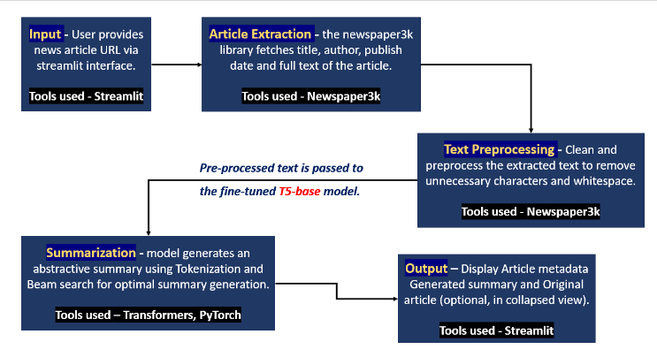
(Figure 1: System Pipeline)

Results

The performance of the T5-base and BART-base models was evaluated using ROUGE scores, which quantitatively assess the quality of generated summaries based on their overlap with human-written references [5] from the SAMSUM dataset. As illustrated in Figure 2: Evaluation Plot, T5-base significantly outperformed BART-base across all evaluated ROUGE metrics:
- ROUGE-1: T5-base achieved a score of 47%, while BART-base scored 26%.
- ROUGE-2: T5-base reached 48%, compared to BART-base's 23%.
- ROUGE-L: T5-base scored 45%, whereas BART-base managed only 23%.
- F1 Score: The F1 Score for T5-base was notably higher than that of BART-base(see Figure 2: Evaluation Results Plot).
These results confirm that T5-base is more effective in generating coherent and contextually relevant summaries for news articles derived from dialog-style inputs.

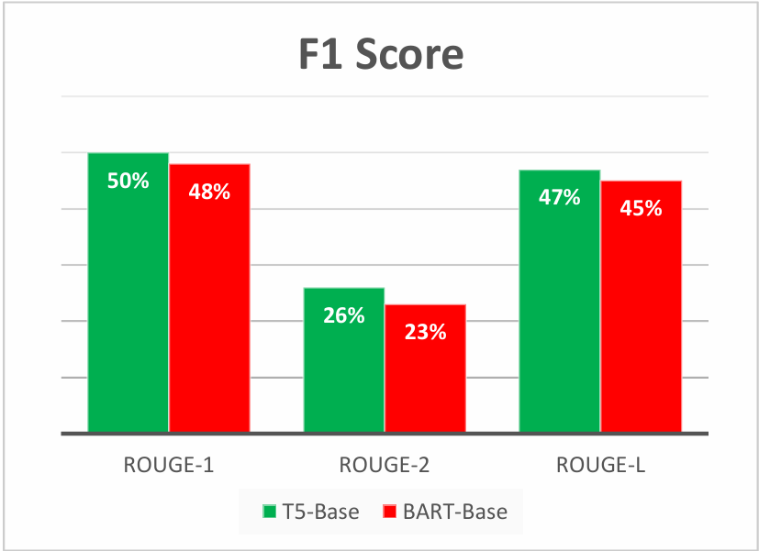
(Figure 2: Evaluation Results Plot)
Overall, these results affirm the effectiveness of using T5-base for abstractive summarization in news articles while providing a robust tool for users needing quick access to essential information without compromising on quality or accuracy.

Conclusion

This research demonstrates the effectiveness of using T5-base for automated text summarization of news articles due to its superior performance in ROUGE evaluations compared to BART-base when trained on dialog-style human-written summaries from the SAMSUM dataset. The implementation via a Streamlit interface provides a practical tool for users seeking concise summaries from lengthy articles while maintaining access to relevant article information.
Future work could explore further enhancements by integrating additional datasets or experimenting with other transformer architectures such as GPT or Pegasus to improve summary quality even further [9]. Additionally, user feedback could be solicited through surveys or usability tests conducted post-deployment; this feedback would be invaluable in refining both interface design elements as well as functionality based on real-world usage scenarios.

References

- C. Raffel et al., “Exploring the Limits of Transfer Learning with a Unified Text-to-Text Transformer,” arXiv.org, 2019. https://arxiv.org/abs/1910.10683
- ‌S. Narayan, S. B. Cohen, and M. Lapata, “Don’t Give Me the Details, Just the Summary! Topic-Aware Convolutional Neural Networks for Extreme Summarization,” arXiv.org, 2018. https://arxiv.org/abs/1808.08745v1 (accessed Jan. 05, 2025).
- ‌ B. Gliwa, I. Mochol, M. Biesek, and A. Wawer, “SAMSum Corpus: A Human-annotated Dialogue Dataset for Abstractive Summarization,” Proceedings of the 2nd Workshop on New Frontiers in Summarization, 2019, doi: https://doi.org/10.18653/v1/d19-5409.
- ‌ Ramesh Nallapati, B. Zhou, Santos, Caglar Gulcehre, and B. Xiang, “Abstractive Text Summarization Using Sequence-to-Sequence RNNs and Beyond,” Feb. 2016, doi: https://doi.org/10.48550/arxiv.1602.06023.
- ‌ C.-Y. Lin, “ROUGE: A Package for Automatic Evaluation of Summaries,” aclanthology.org, Jul. 01, 2004. https://aclanthology.org/W04-1013/
- ‌ C. Niu, C. Li, V. Ng, J. Ge, L. Huang, and B. Luo, “SPT-code,” Proceedings of the 44th International Conference on Software Engineering, May 2022, doi: https://doi.org/10.1145/3510003.3510096.
- ‌ Hugging Face, “Transformers,” huggingface.co. https://huggingface.co/docs/transformers/index
- ‌ Streamlit, “Streamlit Docs,” docs.streamlit.io, 2024. https://docs.streamlit.io/
- ‌ T. Wolf et al., “Transformers: State-of-the-Art Natural Language Processing,” Proceedings of the 2020 Conference on Empirical Methods in Natural Language Processing: System Demonstrations, pp. 38–45, 2020, doi: https://doi.org/10.18653/v1/2020.emnlp-demos.6.

